**FOOD AND NUTRITION II**

**Compiled By:**

**Olukunmi ’Lanre Olaitan,** *D.PHE.(Lag); B.Sc. (Ed.); M.Ed.; Ph.D.(Ilorin); RN (NMCN); FICC; FNRCS, MARHP (Minn. USA); MUNSCN(Geneva); MTRCN (Nig.); ECD; EONC; YSRH; FGM/C; GSRH (USAID/JHU, MD. USA); CIH (UK); CE&IE (Finland)* ***(Professor, Human Sexuality, Reproductive & Family Health Specialist, including Human Fertility, HIV/AIDS, Public Health Education & Promotion, Nutrition Education, Nursing, Women and Adolescent Health, Wellness & Fitness Consultant)***

***University of Ilorin, Ilorin, Nigeria***

**Email:** [olaitan.ol@unilorin.edu.ng](mailto:olaitan.ol@unilorin.edu.ng) **OR:** [lanreolives@yahoo.com](mailto:lanreolives@yahoo.com) **OR:** [ololahealth@gmail.com](mailto:ololahealth@gmail.com) **Tel: +234(0) 803 4228 042.**

**Meaning of Nutrition**

**Nutrition** is the study of **nutrients in food**, how the body uses them, and the **relationship between diet, health, and disease**.

**Nutrition** also focuses on how people can **use dietary choices to reduce the risk of disease**, what happens if a person has too much or too little of a nutrient, and how allergies work.

**Meaning of Ideal Nutrition**

**Ideal nutrition** refers to **good nutrition**, which is **different from diet** for it is quality of food itself. It is sometimes refers to as **optimal nutrition** which involves **balancing of feed ingredients and nutrients to meet the requirements of an individual** for basic maintenance of physiological function, for growth, and for reproduction and lactation.

**It could also be related to a perfect diet** which should: Be High in Nutrients. Move away from the food group philosophy and toward a nutrient philosophy. **Eat nutrients: proteins, carbohydrates, fats, vitamins, minerals, and water**. You do not specifically need to consume milk and milk alternatives, meat and meat alternatives, and grain products

**Nutrients** provide **nourishment**. **Proteins,**[**carbohydrates**](https://www.medicalnewstoday.com/articles/161547.php)**, fat,**[**vitamins**](https://www.medicalnewstoday.com/articles/195878.php)**, minerals, fiber, and water are all nutrients**. If people do not have the right balance of nutrients in their diet, their risk of developing certain health conditions increases.

**The two categories of nutrients are Macronutrients and Micronutrients.**

**Macronutrients** are nutrients that **people need in relatively large quantities**. Examples are **carbohydrates, proteins, fats and water**.

**Carbohydrates**

Sugar, starch, and fiber [are types](https://www.diabetes.org/nutrition/understanding-carbs/get-to-know-carbs) of carbohydrates.

**Sugars** are simple carbs. The body quickly breaks down and absorbs sugars and processed starch. They can provide rapid energy, but they do not leave a person feeling full. They can also cause a spike in blood sugar levels. Frequent sugar spikes increase the risk of [**type 2 diabetes**](https://www.medicalnewstoday.com/info/diabetes/type2diabetes.php) and its complications.

**Fiber** is also a carbohydrate. The body breaks down some types of fiber and uses them for energy; others are metabolized by gut bacteria, while other types pass through the body.

**Fiber and unprocessed starch** are complex carbs. It takes the body some time to break down and absorb complex carbs. After eating fiber, a person will feel full for longer. Fiber may also reduce the risk of [diabetes](https://www.medicalnewstoday.com/info/diabetes/), cardiovascular disease, and [colorectal cancer](https://www.medicalnewstoday.com/articles/155598.php). Complex carbs are a more healthful choice than sugars and refined carbs.

**Proteins**

**Proteins** consist of **amino acids**, which are organic compounds that occur naturally.

There are [**20 amino acids**](https://www.nutrition.org.uk/nutritionscience/nutrients-food-and-ingredients/protein.html?start=1&__cf_chl_jschl_tk__=e848e22815e9f8890ffe145f853ac0c1d8a5778a-1574949815-0-AW0aJNPO2Q0hGhAvDUgMuHY1p8yAokEo8sDCCXlgZUadd9Z7Xa9ilhap7D1SQZsuSM-JMysjKsJFaRjL9pMoOx0a8UN_z_AmtbnQhgfT-y4Ut2Dyve67eThHBHN-ZzTBFgPfsa6F2yzehqFb-CCNiGptCEQUmMB-7lpiqirWttdOYUkPPwwBetT6Cw3UuE8APUdkEJW8J0fZGThjXaCEkjnV6w0cmGyGSzRUhO7vC27XNo3EcQewYvWuEA06vYsOA2IoSOghO-gAV-8-R96u0tLCGHuzObuhjw6oXWIrKF2cqS7fJ4TS8LJTaSgOVqvRijgE8c4QoApnATt1lQh9xYqFo9nVXU5EWXgu9sECzet7v4b6hpUBH9O_afSS5nwZvotU7FyzyRhxmx-PA2k58JtyhyCpDt0MRRYNCcT_CMj5). Some of these are [essential](https://www.ncbi.nlm.nih.gov/pmc/articles/PMC4897092/), which means people need to obtain them from food. The body can make the others.

Some foods provide complete protein, which means they contain all the essential amino acids the body needs. Other foods contain various combinations of amino acids.

Most plant-based foods do not contain complete protein, so a person who follows a vegan diet needs to eat a range of foods throughout the day that provides the essential amino acids.

**Fats**

**Fats** are essential for:

* **lubricating** joints
* helping organs produce **hormones**
* enabling the body to **absorb** certain vitamins
* reducing [**inflammation**](https://www.medicalnewstoday.com/articles/248423.php)
* preserving **brain** health

Too much fat can lead to [obesity](https://www.medicalnewstoday.com/info/obesity/how-much-should-i-weigh.php), high [cholesterol](https://www.medicalnewstoday.com/articles/9152.php), liver disease, and other health problems.

However, the type of fat a person eats makes a difference. Unsaturated fats, such as olive oil, are more healthful than saturated fats, which tend to come from animals.

**Water**

The adult human body is [**up to 60%**](https://www.usgs.gov/special-topic/water-science-school/science/water-you-water-and-human-body?qt-science_center_objects=0#qt-science_center_objects)**water**, and it needs water for many processes. Water contains **no**[**calories**](https://www.medicalnewstoday.com/articles/245588.php), and it does not provide energy.

Many people recommend consuming **2 liters, or 8 glasses, of water a day**, but it can also come from dietary sources, such as fruit and vegetables. Adequate hydration will result in pale yellow urine.

Requirements will also depend on an individual’s body size and age, environmental factors, activity levels, health status, and so on.

**Micronutrients**

**Micronutrients** are essential in **small amounts**. They include **vitamins and minerals**. Manufacturers sometimes add these to foods. Examples include fortified cereals and rice.

## Difference Between Micronutrients and Macronutrients

|  |  |  |
| --- | --- | --- |
| ****Basis**** | Micronutrients | Macronutrients |
| Functions | Micronutrients are used for various metabolic processes such as enzyme activation and cell signaling. | Macronutrients are primarily used for energy production, growth, and maintenance of tissues |
| Types | Micronutrients include vitamins and minerals. | Macronutrients include carbohydrates, proteins, and fats. |
| Amounts required | Micronutrients are required in smaller amounts, typically measured in milligrams or micrograms. | Macronutrients are required in larger amounts, typically measured in grams per day or per kilogram of body weight. |
| Deficiencies | The deficiencies in micronutrients can lead to specific deficiencies such as anaemia, goitre signalling, or scurvy. | Deficiencies in macronutrients can lead to malnutrition, obesity, or other health problems. |
| Sources | Micronutrients are obtained from a variety of food sources including fruits, vegetables, dairy products, and supplements. | Macronutrients are usually obtained from food sources such as fruits, vegetables, and meats. |
| Examples | Micronutrients include iron, zinc, and vitamin C. | Macronutrients include glucose, amino acids, and fatty acids |

**Minerals**

The body needs **carbon, hydrogen, oxygen, and nitrogen**.

It also needs dietary minerals, such as **iron,**[**potassium**](https://www.medicalnewstoday.com/articles/287212.php), and so on.

In most cases, a varied and balanced diet will provide the minerals a person needs. If a deficiency occurs, a doctor may recommend supplements.

Some of the minerals the body needs to function well.

**Potassium**

**Potassium** is an **electrolyte**. It enables the **kidneys, the heart, the muscles, and the nerves to work properly**. The *2015–2020 Dietary Guidelines* recommend that adults consume [4,700 milligrams](https://health.gov/dietaryguidelines/2015/guidelines/appendix-7/) (mg) of potassium each day.

Too little can lead to [**high blood pressure**](https://www.medicalnewstoday.com/articles/159283.php)**,**[**stroke**](https://www.medicalnewstoday.com/articles/7624.php)**, and**[**kidney stones**](https://www.medicalnewstoday.com/articles/154193.php).

Too much may be **harmful to people with kidney disease**.

Avocados, coconut water, [bananas](https://www.medicalnewstoday.com/articles/271157.php), dried fruit, squash, beans, and lentils are good sources.

**Sodium**

Sodium is an **electrolyte** [that helps](https://medlineplus.gov/sodium.html):

* maintain **nerve and muscle function**
* regulate **fluid levels** in the body

Too little can lead to **hyponatremia**. Symptoms include **lethargy, confusion, and**[**fatigue**](https://www.medicalnewstoday.com/articles/248002.php)**.**

Too much can lead to **high blood pressure**, which increases the risk of **cardiovascular disease and stroke.**

Table salt, which is made up of **sodium and chloride**, is a popular condiment. However, most people consume too much sodium, as it already occurs naturally in most foods.

**Experts urge people not to add table salt to their diet**. Current guidelines recommend consuming **no more than 2,300 mg of sodium a day**, or around **one teaspoon**.

This recommendation includes both naturally-occurring sources, as well as salt a person adds to their food. People with high blood pressure or kidney disease should eat less.

**Calcium**

The body [needs calcium](https://ods.od.nih.gov/factsheets/Calcium-HealthProfessional/) to form **bones and teeth**. It also supports the **nervous system, cardiovascular health, and other functions**.

Too little can cause **bones and teeth to weaken**. Symptoms of a severe deficiency include tingling in the fingers and changes in heart rhythm, which can be life-threatening.

Too much can lead to [constipation](https://www.medicalnewstoday.com/articles/150322.php), **kidney stones, and reduced absorption of other minerals.**

Current guidelines for adults recommend consuming **1,000 mg a day, and 1,200 mg for women aged 51 and over**.

Good sources include **dairy products, tofu, legumes,and green, leafy vegetables**.

**Phosphorus**

Phosphorus is present in **all body cells and**[**contributes to**](https://ods.od.nih.gov/factsheets/Phosphorus-Consumer/)**the health of the bones and teeth**.

Too little phosphorus can lead to **bone diseases, affect appetite, muscle strength, and coordination**. It can also result in [**anemia**](https://www.medicalnewstoday.com/articles/158800.php), a higher **risk of infection,** **burning or prickling sensations** in the skin, and confusion.

Too much in the diet is **unlikely to cause health problems though toxicity is possible from supplements**, medications, and phosphorus metabolism problems.

Adults should aim to consume around [**700 mg**](https://health.gov/dietaryguidelines/2015/guidelines/appendix-7/)**of phosphorus each day**. Good sources include **dairy products, salmon, lentils, and cashews**.

**Magnesium**

[**Magnesium**](https://www.medicalnewstoday.com/articles/286839.php) [contributes to](https://ods.od.nih.gov/factsheets/Magnesium-HealthProfessional/) **muscle and nerve function**. It helps **regulate**[**blood pressure**](https://www.medicalnewstoday.com/articles/270644.php)**and blood sugar** levels, and it enables the body to produce proteins, bone, and DNA.

Too little magnesium can eventually lead to **weakness, nausea, tiredness, restless legs, sleep** conditions, and other symptoms.

Too much can result **in digestive and, eventually, heart problems**.

**Nuts, spinach, and beans** are good sources of magnesium. Adult **females need**[**320 mg**](https://health.gov/dietaryguidelines/2015/guidelines/appendix-7/)**of magnesium each day, and adult males need 420 mg**.

**Zinc**

**Zinc** plays a role in the health of **body cells, the immune system, wound healing**, and the creation of proteins.

Too little can lead to [**hair loss**](https://www.medicalnewstoday.com/articles/70956.php)**, skin sores, changes in taste or smell,and**[**diarrhea**](https://www.medicalnewstoday.com/articles/158634.php), but this is rare.

Too much can lead to **digestive problems and**[**headaches**](https://www.medicalnewstoday.com/articles/73936.php).

Adult **females need**[**8 mg**](https://health.gov/dietaryguidelines/2015/guidelines/appendix-7/)**of zinc a day, and adult males need 11 mg**. Dietary sources include oysters, beef, fortified breakfast cereals, and baked beans.

**Iron**

**Iron** is [crucial for the **formation**](https://ods.od.nih.gov/factsheets/Iron-HealthProfessional/) of **red blood cells**, which carry oxygen to all parts of the body. It also plays a role in forming connective tissue and creating hormones.

Too little [can result](https://www.medicalnewstoday.com/articles/324397.php) in **anemia,** including **digestive issues, weakness, and difficulty thinking**.

Too much can lead to **digestive problems, and very high levels can be fatal**.

Good sources include **fortified cereals, beef liver, lentils, spinach, and tofu**. Adults need [**8 mg**](https://health.gov/dietaryguidelines/2015/guidelines/appendix-7/)**of iron a day**, but **females need 18 mg** during their reproductive years.

**Manganese**

The body uses manganese to [**produce energy**](https://ods.od.nih.gov/factsheets/Manganese-HealthProfessional/), it plays a role in **blood clotting**, and it supports the **immune system**.

Too little can result in **weak bones** in children, **skin rashes in men, and mood changes in women**.

Too much can lead to **tremors, muscle spasms, and other symptoms**, but only with very high amounts.

Mussels, hazelnuts, **brown rice, chickpeas, and spinach** all provide manganese. Male adults need [**2.3 mg**](https://health.gov/dietaryguidelines/2015/guidelines/appendix-7/) of manganese each day, and females need **1.8 mg**.

**Copper**

[**Copper**](https://www.medicalnewstoday.com/articles/288165.php) [helps the body](https://ods.od.nih.gov/factsheets/Copper-HealthProfessional/) make **energy** and produce connective tissues and blood vessels.

Too little copper can lead to **tiredness**, **patches of light** **skin**, high cholesterol, and connective tissue disorders. This is rare.

Too much copper can result in **liver damage, abdominal pain, nausea, and diarrhea**. Too much copper also reduces the absorption of zinc.

Good sources include **beef liver, oysters, potatoes, mushrooms, sesame seeds, and sunflower seeds**. Adults need [**900 micrograms**](https://health.gov/dietaryguidelines/2015/guidelines/appendix-7/) (mcg) of copper each day.

**Selenium**

[**Selenium**](https://www.medicalnewstoday.com/articles/287842.php) is made up of over **24 seleno proteins**, and it plays a [crucial role](https://ods.od.nih.gov/factsheets/Selenium-HealthProfessional/) in **reproductive and thyroid health**. As an [antioxidant](https://www.medicalnewstoday.com/articles/301506.php), it can also prevent cell damage.

Too much selenium can cause **garlic breath, diarrhea, irritability, skin rashes, brittle hair or nails**, and other symptoms.

Too little can result in [**heart disease**](https://www.medicalnewstoday.com/articles/237191.php)**,**[**infertility**](https://www.medicalnewstoday.com/articles/165748.php)**in men, and**[**arthritis**](https://www.medicalnewstoday.com/articles/7621.php).

Adults **need**[**55 mcg**](https://health.gov/dietaryguidelines/2015/guidelines/appendix-7/) of selenium a day.

Brazil nuts are an excellent source of selenium. Other plant sources include **spinach**, **oatmeal**, and **baked beans**. Tuna, ham, and enriched **macaroni** are all excellent sources.

**Vitamins**

People **need small amounts of various vitamins**. Some of these, such as vitamin C, are also antioxidants. This means they help protect cells from damage by removing toxic molecules, known as free radicals, from the body.

Vitamins can be:

**Water-soluble**: The eight B vitamins and vitamin C

**Fat-soluble**: Vitamins A, D, E, and K

**Water soluble vitamins**

People need to consume water-soluble vitamins regularly because the body removes them more quickly, and it cannot store them easily.

|  |  |  |  |
| --- | --- | --- | --- |
| **Vitamin** | **Effect of too little** | **Effect of too much** | **Sources** |
| B-1 ([thiamin](https://ods.od.nih.gov/factsheets/Thiamin-HealthProfessional/)) | Beriberi  Wernicke-Korsakoff syndrome | Unclear, as the body excretes it in the urine. | Fortified cereals and rice, pork, trout, black beans |
| B-2 ([riboflavin](https://ods.od.nih.gov/factsheets/Riboflavin-HealthProfessional/)) | Hormonal problems, skin disorders, swelling in the mouth and throat | Unclear, as the body excretes it in the urine. | Beef liver, breakfast cereal, oats, yogurt, mushrooms, almonds |
| B-3 ([niacin](https://ods.od.nih.gov/factsheets/Niacin-HealthProfessional/)) | Pellagra, including skin changes, red tongue, digestive and neurological symptoms | Facial flushing, burning, itching, headaches, rashes, and dizziness | Beef liver, chicken breast, brown rice, fortified cereals, peanuts. |
| B-5 ([pantothenic acid](https://ods.od.nih.gov/factsheets/PantothenicAcid-HealthProfessional/)) | Numbness and burning in hands and feet, fatigue, stomach pain | Digestive problems at high doses. | Breakfast cereal, beef liver, shiitake mushroom, sunflower seeds |
| B-6 ([pyridoxamine, pyridoxal](https://ods.od.nih.gov/factsheets/VitaminB6-HealthProfessional/)) | Anemia, itchy rash, skin changes, swollen tongue | Nerve damage, loss of muscle control | Chickpeas, beef liver, tuna, chicken breast, fortified cereals, potatoes |
| B-7 ([biotin](https://ods.od.nih.gov/factsheets/Biotin-HealthProfessional/)) | Hair loss, rashes around the eyes and other body openings, [conjunctivitis](https://www.medicalnewstoday.com/articles/157671.php) | Unclear | Beef liver, egg, salmon, sunflower seeds, sweet potato |
| B-9 ([folic acid, folate](https://ods.od.nih.gov/factsheets/Folate-HealthProfessional/)) | Weakness, fatigue, difficulty focusing, heart palpitations, shortness of breath | May increase [cancer](https://www.medicalnewstoday.com/info/cancer-oncology/) risk | Beef liver, spinach, black-eyed peas, fortified cereal, asparagus |
| B-12 ([cobalamins](https://ods.od.nih.gov/factsheets/VitaminB12-HealthProfessional/)) | Anemia, fatigue, constipation, weight loss, neurological changes | No adverse effects reported | Clams, beef liver, fortified yeasts, plant milks, and breakfast cereals, some oily fish. |
| Vitamin C ([ascorbic acid](https://ods.od.nih.gov/factsheets/VitaminC-Consumer/)) | Scurvy, including fatigue, skin rash, gum inflammation, poor wound healing | Nausea, diarrhea, stomach cramps | Citrus fruits, berries, red and green peppers, kiwi fruit, broccoli, baked potatoes, fortified juices. |

**Fat-soluble vitamins**

The body absorbs fat-soluble vitamins through the intestines with the help of fats (lipids). The body can store them and does not remove them quickly. People who follow a low-fat diet may not be able to absorb enough of these vitamins. If too many build up, problems can arise.

|  |  |  |  |
| --- | --- | --- | --- |
| **Vitamin** | **Effect of too little** | **Effect of too much** | **Sources** |
| Vitamin A ([retinoids](https://ods.od.nih.gov/factsheets/VitaminA-HealthProfessional/)) | Night blindness | Pressure on the brain, nausea, dizziness, skin irritation, joint and bone pain, orange pigmented skin color | Sweet potato, beef liver, spinach, and other dark leafy greens, carrots, winter squash |
| [Vitamin D](https://ods.od.nih.gov/factsheets/VitaminD-HealthProfessional/) | Poor bone formation and weak bones | Anorexia, weight loss, changes in heart rhythm, damage to cardiovascular system and kidneys | Sunlight exposure plus dietary sources: cod liver oil, oily fish, dairy products, fortified juices |
| [Vitamin E](https://ods.od.nih.gov/factsheets/VitaminE-HealthProfessional/) | Peripheral [neuropathy](https://www.medicalnewstoday.com/articles/147963.php), retinopathy, reduced immune response | May reduce the ability of blood to clot | Wheatgerm, nuts, seeds, sunflower and safflower oil, spinach |
| [Vitamin K](https://ods.od.nih.gov/factsheets/vitaminK-HealthProfessional/) | Bleeding and hemorrhaging in severe cases | No adverse effects but it may interact with blood thinners and other drugs | Leafy, green vegetables, soybeans, [edamame](https://www.medicalnewstoday.com/articles/280285.php), okra, natto |

Multivitamins are available for purchase in stores or online, but people should speak to their doctor before taking any supplements, to check that they are suitable for them to use.

**Antioxidants**

Some nutrients also act as antioxidants. These may be vitamins, minerals, proteins, or other types of molecules. They help the body remove toxic substances known as free radicals, or reactive oxygen species. If too many of these substances remain in the body, cell damage and disease can result.

**Dietitian vs. nutritionist**

**A registered dietitian nutritionist (RD or RDN)** studies food, nutrition, and dietetics. To become a registered dietitian, a person needs to attend an accredited university, follow an approved curriculum, complete a rigorous internship, pass a licensure exam, and complete 75 or more continuing education hours every 5 years. Dietitians work in private and public healthcare, education, corporate wellness, research, and the food industry.

**A nutritionist** learns about nutrition through self-study or formal education, but they do not meet the requirements to use the titles RD or RDN. Nutritionists often work in the food industry and in food science and technology.

**Evaluation**

Define Nutrition: is the study of food and how it affects the body. People need to consume a varied diet to obtain a wide range of nutrients.

Describe a diet that can benefit people’s health: A diet that is rich in plant-based foods and that limits added animal fats, processed foods, and added sugar and salt is most likely to benefit a person’s health.

What is the ideal diet?: **A perfect diet** should be High in Nutrients. Move away from the food group philosophy and toward a nutrient philosophy. Eat nutrients: proteins, carbohydrates, fats, vitamins, minerals, and water. You do not specifically need to consume milk and milk alternatives, meat and meat alternatives, and grain products

What does a nutritionist do for you?: A **nutritionist** takes a holistic approach in helping individuals or their clients in altering their eating habits and living healthy lifestyles. They help clients reach the goals that they have set. A **nutritionist** may work on weight loss, nutritional or hormonal balance, digestion, or food allergies.

How do you meet your daily nutritional requirements?: **To meet your body's regular nutritional needs, you should consume:**

1. a wide variety of nutritious foods.
2. water on a **daily** basis.
3. enough kilojoules for energy, with carbohydrates as the preferred source.
4. essential fatty acids from foods such as oily fish, nuts, avocado.
5. adequate protein for cell maintenance and repair.

What is a balanced diet?: A **balanced diet** is a **diet** that contains differing kinds of foods in certain quantities and proportions so that the requirement for calories, proteins, minerals, vitamins and alternative nutrients is adequate and a small provision is reserved for additional nutrients to endure the short length of leanness.

**Healthy Nutrition at Home**

# Making healthy eating choices at home matters

Home environment is important when it comes to healthy eating.

The home is the place where many food activities occur, including preparing, preserving, cooking and eating food.

It is also the place where many food decisions are made. These include:

* **planning** **what** to eat
* **deciding** **when** to eat
* **deciding how much** to eat

The foods in your home influence what you eat. Having healthier options available makes it easier to prepare and eat healthy meals and snacks. Likewise, having [highly processed foods](https://food-guide.canada.ca/en/tips-for-healthy-eating/commonly-used-terms/#s8) available may cause you to eat more of these foods without you even realizing it.

**When food is prepared and cooked at home**, it allows individual to:

* **rely less** on food from:
  + restaurants
  + fast food outlets
  + work or school cafeterias
* **choose** what goes in your food
* **decrease** the amount of highly **processed food** you buy and eat
* **decrease** the amount of **sodium, sugars or saturated fat** in your meals
* **add** more **vegetables, fruit, whole grain** foods and **plant-based protein** foods to your meals

To make healthy food choices at home, these ideas below are important

**Plan what you’re going to eat**

Find healthy and tasty recipes that you and those in your household will enjoy.

Follow the healthy eating recommendation to help you [plan ahead](https://food-guide.canada.ca/en/healthy-eating-recommendations/cook-more-often/plan-what-you-eat).

**Shop smart**

Only buy and bring home the foods you need and know you will eat. This can help you:

* stay on budget
* cut down on impulse buys
* reduce food waste in the home

**Have healthy options available**

Pre-wash, chop and store healthy foods to make them easier to use when they are needed. Properly canning, preserving and freezing seasonal foods can help you have these types of foods all year-round.

**Limit the number of highly processed foods**

Having fewer of these foods available in your home can help you:

* eat fewer of them
* use fewer of them when preparing meals and snacks

Follow the healthy eating recommendation to help you [limit highly processed foods](https://food-guide.canada.ca/en/healthy-eating-recommendations/limit-highly-processed-foods).

**Grow and harvest your own food**

Growing and harvesting your own food gives you access to fresh seasonal foods. If you don’t have the space to grow food at home or are new to gardening, consider joining a community garden.

**Decrease food waste**

Almost half of the [food waste](https://food-guide.canada.ca/en/tips-for-healthy-eating/commonly-used-terms/#s) created across the food system is produced at the household level. You can help reduce food waste by:

* adjusting recipes
* reusing leftovers
* storing and freezing food
* using all parts of a food like:
  + beet greens, which can be chopped into a salad
  + tougher parts of meat, which can be stewed or slow cooked
  + broccoli stems, which can be sautéed in a stir fry or used to make a vegetable broth

**Creating a home that supports healthy eating habits**

A home environment that supports healthy eating habits is just as important as the foods you eat. These habits help form a healthy [eating pattern](https://food-guide.canada.ca/en/tips-for-healthy-eating/commonly-used-terms/#s4).

Set yourself up for success with these strategies:

* Organize your fridge and pantry to make it easy to grab healthy foods
* Keep foods that can be used in a variety of meals available in your kitchen
* Have a set place where you can eat and enjoy meals with others in your household
* Put perishable foods in the fridge or freezer as soon as you get home from shopping

You can be a role model for others in your household. Your healthy eating habits may encourage those around you to make healthy choices too.

**Eating Healthy When You are Working from Home**

**1. Don’t work in (or near) the kitchen.** Try to set up your desk in an area that’s not near the kitchen. You might be tempted to wander over and check the [fridge](https://health.clevelandclinic.org/10-ways-to-stock-your-fridge-for-weight-loss/) (for the tenth time) if it’s constantly in your line of vision. Decide that the only time you’ll be in your kitchen during the workday is when you’re getting ready to have a planned snack or meal. (More on that below!) If this is hard to follow, hang a sign on your fridge and pantry to remind you that the kitchen is closed until the next scheduled meal or snack.

2.  **Plan your snack and meal times.** Just as you schedule and plan out the rest of your day (get up, workout, shower), establish when throughout the day you’re going to eat. If you know you like to eat lunch around noon, plan for that. And if you like to have a [snack](https://health.clevelandclinic.org/how-to-choose-healthy-snacks-that-wont-derail-your-otherwise-healthy-diet/) in the late afternoon, plan for that as well. Treat food like you would in the office. You can’t be grazing all day long when you’re there – so act the same way at home.

3. **Make sure you actually eat.** Once you hit the ground running, err, working, it can be hard to take a break to actually eat. But it’s important to know your [hunger signs](https://health.clevelandclinic.org/decoding-your-hunger-are-you-really-hungry-or-not/) and realize that not eating can affect your alertness and productivity. Plus, eating throughout the day can save you from being a big hangry mess once 5 o’clock rolls around. If needed, set an alarm on your phone to remind you to get up and eat something.

4 **Meal prep your lunches.** There’s something freeing about being able to whip up whatever you want to eat for lunch (and not having to stand in line for the work microwave is a huge bonus). But for some people, the freedom is too much, especially when it comes to weekday lunches. If you can, try to [meal prep](https://health.clevelandclinic.org/a-beginners-guide-to-healthy-meal-prep/) your lunches ahead of time, just like you would on days you physically go to work. It doesn’t need to be anything fancy either. A bag of lettuce, precut veggies, grilled chicken and nuts is a simple form of meal prep that takes out all the guess work. Or maybe you’ve decided that you’re going to make a veggie omelet every day for lunch. Precut the vegetables ahead of time so you can quickly cook up a healthy and delicious lunch.

5 **Focus on real food.** [Balanced, nutritious food](https://health.clevelandclinic.org/skip-the-fads-why-you-should-eat-a-real-food-diet/) makes us more productive. It keeps us fuller longer and helps us focus. Understand that what you eat will impact your mood and energy level. Think about this the next time you’re feeling hungry and just want to grab a handful of chocolate from the pantry. Focus on protein, fiber, healthy fats, fruits and veggies. Planning a menu ahead of time will make it easier to avoid noshing on whatever looks tastiest and quickest in the moment.

6 **Drink plenty of water.** Dehydration can lead to headaches and fatigue, which are both not good for your productivity. Just as you’d fill up a water bottle at the office to keep at your desk, keep water next to your work station at home too. If you have water readily available, chances are you’re more likely to drink it, helping you reach your goal of at least 64 ounces per day. (And PLEASE stay away from sugar-loaded [soda and juice](https://health.clevelandclinic.org/diet-soda-and-juice-tied-to-increased-stroke-risk/), both of which can cause you to crash later).

7. **Be careful of too much caffeine.** Having access to endless cups of coffee might seem like a great idea, but tread carefully when it comes to caffeine. Too much is known to cause headaches, anxiety, digestive issues and even [fatigue](https://www.ncbi.nlm.nih.gov/pmc/articles/PMC3280075/) – none of which are ever good, but particularly not good when you’re trying to work. Aim for no more than two cups of coffee per day to avoid the jittery feeling and avoid flavored creamers and other high calorie add-ins!

8. **Don’t buy junk food.** Don’t stock your fridge or pantry like a vending machine. This can lead to eating just because you can! Try you best to keep junk food out of your house, especially foods you know can trigger a binge for you. Out of sight, out of mind.

9. **When you eat, just eat.**You might be tempted to continue working through your lunch break now that your co-workers aren’t physically there. Bu don’t do it! Being distracted during a meal can lead to over-eating and decreased satiety (satisfaction and fullness) from the meal. Instead, take a break from work to sit down at a table to enjoy your lunch and relax for a few minutes. You’ll enjoy the meal more, and it may even help you feel more prepared for the rest of your work day.

10. **Portion out snacks and meals before eating**. Never eat out of the bag or original container, as it’s much harder to control portions that way. Check the serving size on the container if you need extra guidance. For meals, try the healthy plate method: Fill half a 9-inch plate with non-starchy vegetables, one-fourth the plate with a lean protein (poultry, seafood, beans, eggs, tofu, cottage cheese or Greek yogurt) and one-fourth the plate with a high fiber carbohydrate (fruit, whole grains or starchy vegetables).

# HEALTHY EATING DURING QUARANTINE OR ISOLATION FOR COVID-19

**Eating** a **healthy balanced diet** is still essential for **good health and normal immune function**. Therefore, following the recommended way to meet the nutrient needs and keep individual healthy during isolation is essential.

Here are the **principles of healthy eating during quarantine** for [**COVID-19** that you need to know.](https://www.eufic.org/en/page/food-and-coronavirus-covid-19-what-you-need-to-know)

**1**. **Eat plenty of fruits and vegetables**

Fruits and vegetables are among the most important foods for supplying the vitamins, minerals and fibre our body needs **for good health and normal immune function**.

We should aim to **eat**[**at least 5 portions**](https://www.eufic.org/en/healthy-living/article/should-we-forget-five-a-day-not-so-fast)**(equivalent to around 400g) of fruits and vegetables every day**. Fresh, frozen, canned, dried and juiced (**maximum 1 serving per day**) versions all count as a portion.

As different coloured fruits and vegetables provide different combinations of vitamins, minerals and phytochemicals, make sure to add variety to your daily meals where possible.

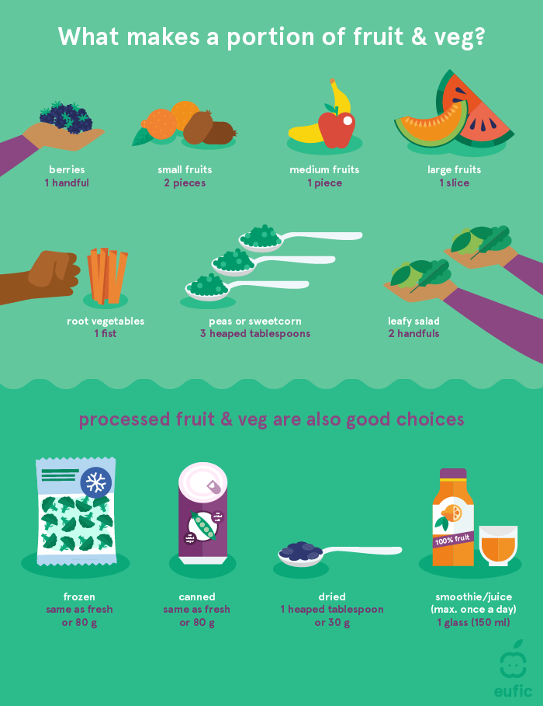

**Figure 1.**What makes a portion of fruit and vegetables?

**2**. **Choose whole grains over refined grains**

[Whole grains](https://www.eufic.org/en/whats-in-food/article/whole-grains-updated-2015), unlike refined grains, maintain most of the structure of the grain, keeping the layers that hold the vitamins, minerals and fibre. In addition, whole grains also provide an important source of [**carbohydrates**](https://www.eufic.org/en/whats-in-food/article/the-basics-carbohydrates) which give us **energy** and can help us **feel fuller for longer periods**.

**3. Replace saturated fats with unsaturated fats**

[Fats](https://www.eufic.org/en/whats-in-food/article/8-facts-on-fats) are an important part of a healthy diet. However, not all fats have the same effect on our health. Swapping saturated fats with [unsaturated fats](https://www.eufic.org/en/whats-in-food/article/the-importance-of-omega-3-and-omega-6-fatty-acids) can help to **lower our LDL (bad) cholesterol levels** and **reduce our risk of heart disease**. We can do this by reducing our intake of foods such as fatty meats, high fat dairy products and tropical oils like coconut oil and adding foods such as nuts, oily fish and [plant oils](https://www.eufic.org/en/whats-in-food/article/how-to-choose-your-culinary-oil) such as olive and rapeseed oil.

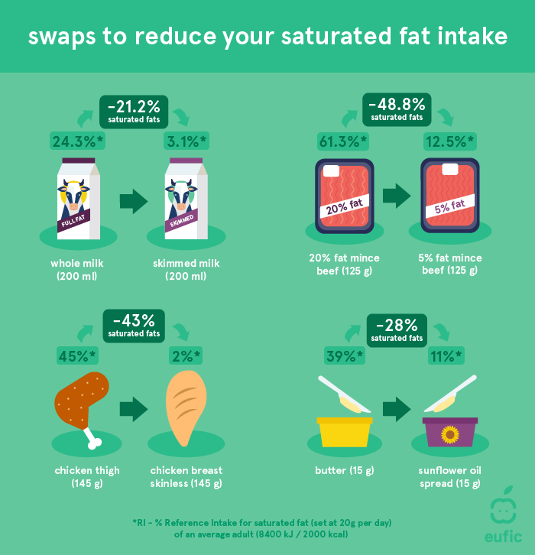

**Figure 2.**Simple food swaps to help reduce your saturated fat intake.

**4. Limit foods and drinks high in fat, sugar and salt**

Foods and drinks high in [fat](https://www.eufic.org/en/whats-in-food/article/8-facts-on-fats), [sugar](https://www.eufic.org/en/whats-in-food/article/daily-sugar-intake-how-many-grams-of-sugar-per-day) and [salt](https://www.eufic.org/en/whats-in-food/category/salt) such as **cookies, potato chips, chocolate and sugary drinks**, when eaten in high amounts can lead us to consume more calories than we need.  As these foods often provide little nutritional benefit, they are not needed for a healthy diet and should only be enjoyed in small amounts and eaten occasionally.

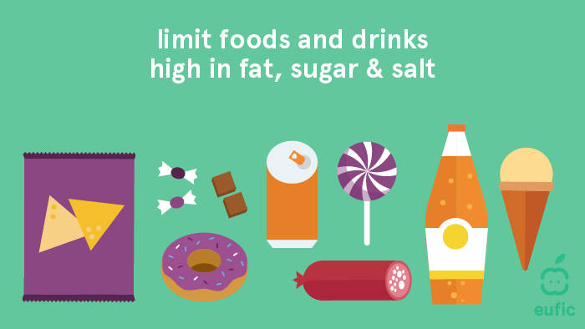

**Figure 3.**Limit foods high in fat, sugar and salt.

**5. Control portion sizes**

It can be difficult to get [portion sizes](https://www.eufic.org/en/healthy-living/article/what-do-you-need-to-know-about-portion-sizes-qa) right, especially when cooking at home. Understanding what the right portion looks like can help us stay in [energy balance](https://www.eufic.org/en/healthy-living/article/energy-balance-explained-video) and avoid under- or overeating. Not all foods have the same portion sizes. See our “[handy” tricks to portion sizes](https://www.eufic.org/en/healthy-living/article/how-to-measure-portion-sizes-with-your-hands-infographic) to get a better understanding of what a healthy portion is for different foods. Remember, children’s portions should be smaller!

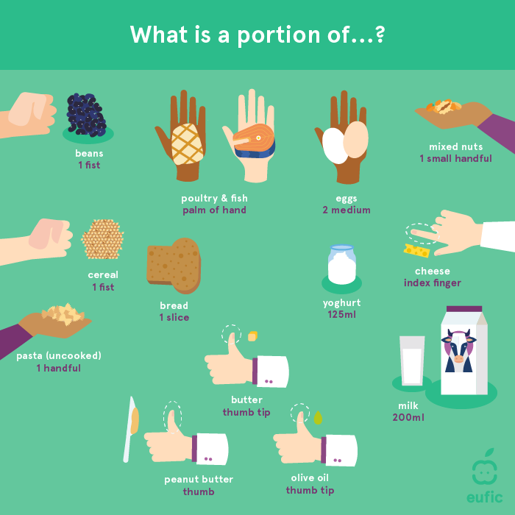

**Figure 4.** What is a portion of…?

**6. Choose both animal and plant-based proteins**

[Protein](https://www.eufic.org/en/whats-in-food/article/what-are-proteins-and-what-is-their-function-in-the-body) is essential **for the healthy functioning of our body and immune system**. We can get protein from both animal- and plant-based sources, such as beans, pulses, fish, eggs, dairy products and meats. **Our protein requirement changes depending on our stage of life**. **Adults are recommended to eat** at **least 0.83 g of protein per kg body weight per day**, equivalent to 58 g/day for a 70 kg adult. We should choose protein-rich foods that not only help us meet our needs but also support a [healthy and sustainable diet](https://www.eufic.org/en/food-production/article/practical-tips-for-a-healthy-and-sustainable-diet).

In case of limited access to fresh meat and fish, frozen and canned versions can provide convenient and nutritious alternatives. However, as the fat and salt content can be high in some canned meats and fish it is important to check the label and choose lower fat and salt varieties. Plant-based proteins such as pulses, cereals, nuts and seeds also have a long shelf-life and can provide convenient protein-rich and nutritious meals or snacks.

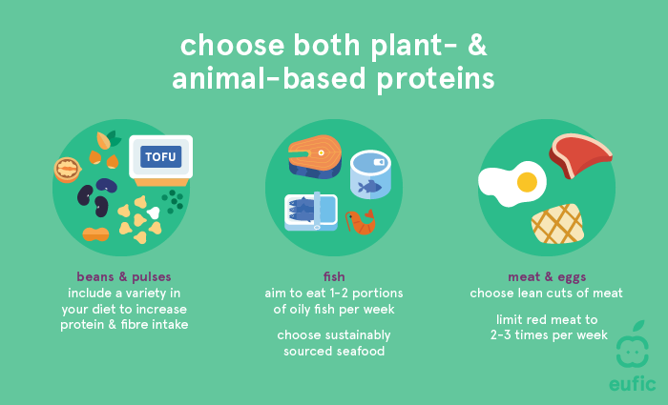

**Figure 5.**Types of plant and animal-based proteins.

**7. Stay hydrated**

Keeping [hydrated](https://www.eufic.org/en/healthy-living/article/how-much-water-should-you-drink-per-day) is essential for overall health. **How much** **water we need depends on our age, sex, weight, height, level of physical activity and environmental conditions** (i.e. hot weather will likely require you to drink more water). Considering that around 20-30% of the water we need comes from our food, the Food Safety Authority has set average recommendations for how much water we should drink per day depending on our age (figure 6)

If you have access to safe tap water, this is the healthiest and cheapest drink. For a refreshing boost, you can add slices of lemon, cucumber, mint or berries. Other drinks such as unsweetened coffee, sparkling water, unsweetened [tea](https://www.eufic.org/en/healthy-living/article/tea-health-and-hydration), iced tea or unsweetened infused or flavoured water are also good choices for hydration.

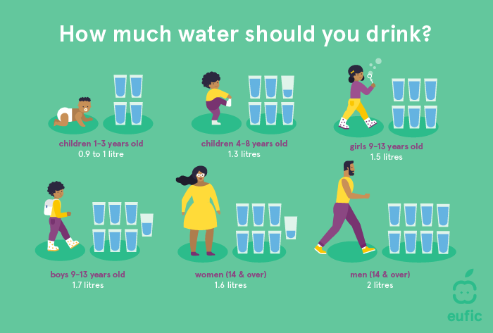

**Figure 6.**Water recommendation for different age groups

**8. Get your dose of vitamin D in isolation**

**The sun is the best source of**[**vitamin D**](https://www.eufic.org/en/whats-in-food/article/a-bright-future-for-vitamin-d), however, during quarantine or self-isolation it may be more difficult to get enough sun exposure to meet our needs. Therefore, it is recommended that individuals who are unable to go outside **eat plenty of vitamin D rich foods** (figure 7) and consider taking a **daily vitamin D supplement**. The recommended vitamin D intake for different age groups are:

* 15 µg/day for adults (18+ years), children (1 – 17 years) and pregnant individuals
* 10 µg/day for infants (7 – 11 months)
* 10 µg/day for breastfeed infants (0 – 7 months)

If you are in self-isolation and have access to an open window, garden or balcony, then short periods (15-30 minutes) of daily sun exposure to the arms and face without sunscreen can help you meet your daily vitamin D needs. However, we should not forget that for [good sun protection](https://www.who.int/uv/sun_protection/en/) we should avoid unprotected sun exposure for more than 30 minutes.

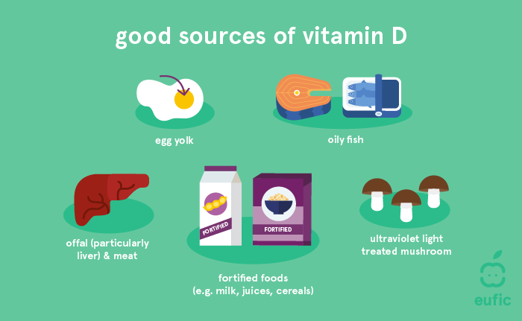

**Figure 7.** Good food sources of vitamin D.

**9. Stay safe while food shopping**

Grocery stores remain open during the COVID-19 pandemic and there is no need to **stockpile** foods as the supply of food to stores remains stable.

The risk of contracting COVID-19 from touching contaminated food packaging is very low and this form of infection has not been reported. In stores, the biggest risk of contamination remains contact with other people and ‘high-touch’ surfaces such as weighing scales, shopping-cart handles or elevator buttons, although many stores are taking measures to sanitize these surfaces. Therefore, **we should, keep the appropriate distance from other people, avoid touching our faces while out shopping, and wash our hands both after returning home from the shop and after handling newly purchased food packaging**. By following these hygiene measures there is no need to disinfect food packaging themselves.

In general, to try and minimise our risk of infection we should take the following measures when food shopping:

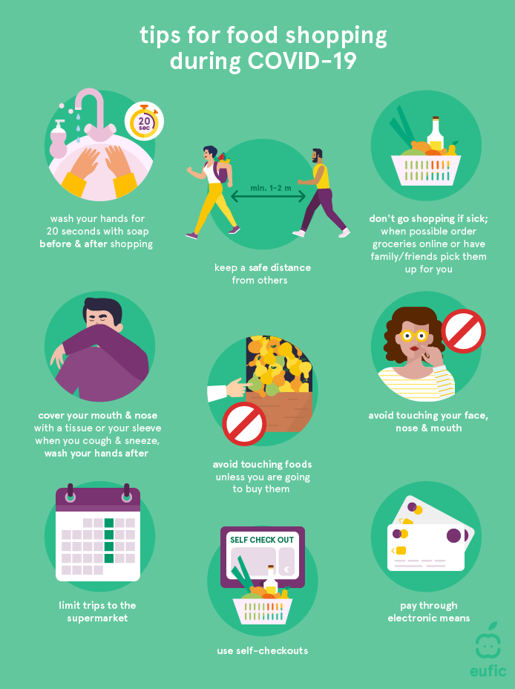

**Figure 8.** Tips for food shopping during COVID-19

**10. Don’t forget about food safety**

Currently **no evidence that COVID-19 is transmitted through eating food**. However, [good **food safety practices**](https://www.eufic.org/en/food-safety/article/food-hygiene-at-home-how-to-avoid-foodborne-illness) are important to **minimise the risk of foodborne illnesses**.

**When handing or preparing food, make sure to**:

* **Wash your hands for 20 seconds** with soap before and after preparing or eating food
* **Cover your mouth and nose** with a tissue or your sleeve when you cough or sneeze and remember to wash your hands after
* **Wash fruits and vegetables** with water before eating them
* **Disinfect surfaces and objects** before and after use
* **Keep raw and cooked foods separate to avoid harmful microbes** from raw foods spreading to ready-to-eat foods
* **Make sure to cook and reheat foods to adequate temperatures (≥72°C for 2 mins)**.

**Healthy Eating Out**

**What is healthy to eat when eating out?**

Focus on what **healthy** items you can add to your plate instead of only what **foods** to avoid. …

**What is the healthiest place to eat out?**

Here are some **fast-food restaurants** that have some healthy options on the menu.

* Mr. Bigg’s., Sweet sensation. Captain Cook. .Royal Eatery. .Tantalizer. Foodco KFC. ..Etc.

**Is it healthy to eat out?: Eating out** for lots of meals **increases your risk of heart disease or stroke**……

**How can I eat healthy and cheap?:** Here are some clever tips that can help you eat healthy on a budget.

1. **Plan** Your Meals,
2. **Stick** **to** Your Grocery **List**,
3. **Cook** at **Home**,
4. Etc.

**What is the number 1 healthiest food in the world?:** The following are some of the most healthful:

* Broccoli, **Apples**. Blueberries. **Avocados**, **Leafy green vegetables, Sweet potatoes**, Etc…

**What meal has the least calories? :** Foods That Contain Almost Zero Calories

1. **Apples**. **leafy green,** Asparagus, Beets, Broccoli, **Cabbage**, Etc..

**Why you should never eat out?:** Consistently dining **out** is **full of hazards** including: **Eating out** is a colossal **waste of money**….

**What are the worst restaurants to eat at?:** The restaurant that is **not neat, clean and spacious**. The sitting arrangement is not in orderly manner. No Table menu and where the cooking environment is unhealthy…..

**How do I begin to eat healthy?:** 1. Follow a **Healthy Eating** Plan….

**Foods That Are Bad for Your Health: Sugary drinks**. Added sugar is one of the worst ingredients in the modern diet, **Most pizzas**, **White bread**. **Most fruit juices**, Etc….

**How often should I eat out?:** If you really want **to** save money, it is recommended limiting yourself to **once a week**….

**Clever Tips to Eat Healthy When Eating Out**

**Read the Menu Before You Go**. ..

Have a Healthy **Snack** Before You Arrive.

**Drink Water** Before and During Your Meal. .Etc….

[**Try these strategies for enjoying a meal out while sticking to a healthy eating plan.**](https://twitter.com/intent/tweet?text=%20Eating+out+doesn%27t+have+to+sabotage+a+healthy+diet.+Follow+these+7+smart-eating+strategies:+http://sm.eatright.org/hlthdineout%20+via+@eatright)

#### 1. Sleuth It Out

#### 2. Don't Split Your Plate

#### 3. Add to Your Meal

#### 4. Don't Go Overly Hungry

#### 5. Watch for the Wording

#### 6. Ask, Ask, Ask

**Abnormal Eating /Nutrition**

**What is abnormal eating?**

**This sometimes may be referred to as eating** **disorders** are serious conditions related to persistent **eating** behaviors that negatively impact your health, your emotions and your ability to function in important areas of life.

The most common **eating** disorders are **anorexia nervosa, bulimia nervosa and binge-eating** disorder.

**Nutritional** disease, any of the **nutrient**-related diseases and conditions that cause illness in humans. They may include **deficiencies or excesses** in the **diet**, **obesity** and **eating disorders**, and **chronic diseases such as cardiovascular disease, hypertension, cancer, and diabetes mellitus**

**Types of eating habits**

1. **Emotional Eater**. This person tends to **eat** when they're **happy**, others when they're **sad** or **stressed**.
2. **Unconscious Eater**. – Eating without knowing, **after thought** eaters
3. **Habitual Eate**r – **Consistent** eaters
4. Critical Eaters. – **purposeful** eaters
5. Sensual Eater. – To proof a point eaters
6. Energy Eater. – Power eaters

**WHAT IS ORTHOREXIA?**

**Orthorexia** is an **unhealthy focus on eating** in a healthy way. Eating nutritious food is good, but if you have **orthorexia**, you obsess about it to a degree that can damage your overall well-being.

**What are the five warning signs of orthorexia?**

Refusing to go out to eat or allowing oneself to be around other types of food. **Isolating oneself** from others because they do not share the same beliefs. **Severe anxiety regarding how food is prepared**. Avoidance of social events involving food for fear of being unable to comply with the diet.

**Which nutritional disorder is related to overeating?**

**Binge eating disorder** (**BED**) is a type of feeding and **eating disorder** that's now recognized as an official diagnosis. It affects almost 2% of people worldwide and can cause additional health issues linked to diet, such as **high cholesterol** levels and **diabetes**.

**What is normal eating?**

**Normal eating** is being able to give some thought to your food selection so you get nutritious food, but not being so wary and restrictive that you miss out on enjoyable food. **Normal eating** is giving yourself permission to **eat** sometimes because you are happy, sad or bored, or just because it feels good.

**What are some problems in eating behavior?**

**Some common experiences include:**

* **depression**.
* **anxiety**.
* **obsessive-compulsive** disorders.
* **phobias** of certain foods.
* **issues** with self-esteem and body image.
* forms of **self-harm** – you may see your **eating problem** as a form of self-harm, or may hurt yourself in other ways too.

**What is excessive eating a sign of?**

**Binge**-**eating** disorder is a serious **eating** disorder in which you frequently consume unusually large amounts of food and feel unable to stop **eating**. Almost everyone overeats on occasion, such as having seconds or thirds of a holiday meal.

**What is the importance of eating habits?**

Eating well is fundamental to good health and well-being. Healthy eating helps us to maintain a healthy **weight** and reduces our risk of **type 2 diabetes**, **high blood pressure**, high **cholesterol** and the risk of developing cardiovascular disease and some cancers.

**What are the 5 healthy habits?**

**These 5 habits are:**

* eating a **healthy diet**.
* getting regular **exercise**.
* not smoking.
* staying at a healthy weight.
* limiting **alcohol**.

**How Starvation Affects the Body**

|  |  |
| --- | --- |
| **Body Area Affected** | **Effects** |
| Cardiovascular system (**heart** and blood vessels) | **Reduced** **heart** size, reduced amount of blood pumped, slow **heart** rate, and low blood pressure Ultimately, **heart** failure |
| Respiratory system | **Slow** breathing and reduced lung capacity Ultimately, respiratory failure |

**What happens when there is an imbalance in your nutrition?**

A **nutritional** deficiency **occurs** when **the** body doesn't absorb or get from food **the** necessary amount of a **nutrient**. Deficiencies can lead to a variety of health problems. These can include digestion problems, skin disorders, stunted or defective bone growth, and even dementia.

**What is a consequence of inadequate nutritional intake?**

**Poor** eating habits such as **insufficient intake** or high **intake** both have adverse **effects** on **health**. These problems include obesity, high blood pressure, high cholesterol, heart disease and stroke, type-2 diabetes, osteoporosis and so on.

**What are the effects of nutrition on health?**

A healthy diet helps children grow and develop properly and reduces their risk of chronic diseases, including obesity. Adults who eat a healthy diet live longer and have a lower risk of obesity, **heart disease**, type 2 diabetes, and certain cancers.

**What are the symptoms of poor nutrition?**

**Signs of Inadequate Nutrition**

* Unexplained **Fatigue**. **Fatigue** is a common side effect of iron deficiency, which can lead to **anemia**, indicated by low levels of red blood cells. ...
* Brittle and **Dry Hair**. ...
* Ridged or Spoon-Shaped **Nails**. ...
* Mouth **Problems**. ...
* **Diarrhea**. ...
* Apathy or **Irritability**. ...
* Lack of **Appetite**.

**What are the ways to improve eating habits?**

**5 Easy Ways to Improve Your Family's Eating Habits:**

1. **Don't skip breakfast**. ​Your mother was right; breakfast is the most important meal of the day! ...
2. **Keep healthy snacks on hand.** Fruits, vegetables, **cheese**, and whole grains are great snacks for hungry kids. ...
3. **Watch your portions**. ...
4. **Eat as a family**. ...
5. **Keep family meals media-free**.

**What causes poor nutrition?**

What Causes Poor Nutrition? Poor eating habits include **under- or over-eating**, not having enough of the healthy **foods** we need each day, or consuming too many types of food and **drink**, which are low in fibre or high in fat, salt and/or sugar.

**How does poor nutrition affect the digestive system?**

A **lack of** food in the **system** can cause **excessive gas** – and lead to a gurgling, wind filled **stomach**. Try and avoid eating large or fatty meals before going to sleep.

**How does poor nutrition affect mental health?**

H**ealthy** diets **can** help with symptoms of **depression and anxiety**. Unhealthy diets have been linked to an increased risk of dementia or stroke.

**How do you fix poor nutrition?**

**Solutions:**

1. **Eat smaller meals** and snacks more frequently. ...
2. **Talk to your provider**. ...
3. **Avoid non-nutritious beverages** such as black coffee and tea; instead choose milk and juices.
4. **Try to eat more protein** and fat, and less simple sugars.
5. **Walk or participate in light activity** to stimulate your appetite.

**How can we prevent poor nutrition?**

The best **way to prevent abnormal nutrition** is to **eat a healthy, balanced diet**.  
**and recognize the following;**

1. plenty of fruit and vegetables.
2. plenty of starchy foods such as bread, rice, potatoes, pasta.
3. some milk and dairy foods or non-dairy alternatives.
4. some sources of protein, such as meat, fish, eggs and beans.

**Malnutrition**

Malnutrition refers to when **a person’s diet does not provide enough nutrients or the right balance of nutrients for optimal health**.

**Malnutrition** occurs when a person gets **too much or too little of certain nutrients**.

**Causes of malnutrition** include inappropriate dietary choices, a low income, difficulty obtaining food, and various physical and [mental health](https://www.medicalnewstoday.com/articles/154543.php) conditions.

**Undernutrition** occurs when they lack nutrients because they eat **too little** food overall.

A person with undernutrition may **lack** [vitamins](https://www.medicalnewstoday.com/articles/195878.php), minerals, and other essential substances that their body needs to function.

**Undernutrition** is one [type of malnutrition](http://www.who.int/features/qa/malnutrition/en/). It occurs when the body does not get enough food. It can lead to delayed growth, low weight, or wasting.

If a person does not get the right balance of nutrients, they can also have malnutrition. It is possible to have [obesity](https://www.medicalnewstoday.com/info/obesity/how-much-should-i-weigh.php) with malnutrition.

When a person has too little food, a limited diet, or a condition that stops their body from obtaining the right balance of nutrients, it can have a severe impact on their health. In some cases, this can become life threatening.

**Malnutrition can lead to**:

* short- and long-term **health problems**
* **slow recovery** from wounds and illnesses
* a higher **risk of infection**
* **difficulty focusing at work or school**

Some deficiencies can trigger specific health problems. For example:

**A lack of vitamin A**

Around the world, many children develop [**vision** problems](https://ods.od.nih.gov/factsheets/VitaminA-HealthProfessional/) due to a lack of vitamin A.

**A lack of vitamin C**

A [lack of vitamin C](https://ods.od.nih.gov/factsheets/VitaminC-HealthProfessional/) can result in [**scurvy**](https://www.medicalnewstoday.com/articles/155758.php). Scurvy is rare in the United States, but it can develop if a person does not have a varied diet with plenty of fresh fruits and vegetables.

Older adults, young children, those who consume a lot of alcohol, and some people with certain mental health conditions may be particularly at risk.

**An overall deficiency**

Lacking all nutrients can lead to [**kwashiorkor**](https://www.medicalnewstoday.com/articles/322453.php), which is a “[severe form of malnutrition](https://www.nhs.uk/conditions/kwashiorkor/).” One symptom of this condition is a distended abdomen.

[**Marasmus**](https://www.medicalnewstoday.com/articles/313185.php) is another potential result of severe nutritional deficiency. A person with marasmus will have very little muscle or fat on their body.

**Symptoms**

Some signs and [symptoms](https://www.nhs.uk/conditions/malnutrition/symptoms/) of malnutrition include:

* a **lack of appetite** or interest in food or drink
* [**tiredness**](https://www.medicalnewstoday.com/articles/248002.php) and irritability
* an **inability to concentrate**
* always feeling **cold**
* [**depression**](https://www.medicalnewstoday.com/articles/8933.php)
* **loss** of fat, muscle mass, and body tissue
* a higher risk of getting **sick** and taking longer to heal
* **longer healing** time for **wounds**
* a higher risk of **complications after surgery**

Eventually, a person may also experience **difficulty breathing and**[**heart failure**](https://www.medicalnewstoday.com/articles/156849.php).

In children, [there may be](https://www.nhs.uk/conditions/malnutrition/symptoms/):

* a **lack** of **growth** and low [body **weight**](https://www.medicalnewstoday.com/info/obesity/how-much-should-i-weigh.php)
* **tiredness** and a **lack** of **energy**
* **irritability** and [**anxiety**](https://www.medicalnewstoday.com/info/anxiety/)
* **slow behavioral and intellectual development**, possibly resulting in learning difficulties

Treatment is possible. In some cases, however, malnutrition can have long-term effects.

[Anorexia nervosa](https://www.medicalnewstoday.com/articles/267432.php) is a mental health condition that can lead to severe malnutrition.

**Causes**

Malnutrition can occur for [various reasons](https://www.nhs.uk/conditions/malnutrition/causes/). The potential causes are the following:

**A low intake of food**

Some people develop malnutrition because there is not enough food available or because they have difficulty eating or absorbing nutrients.

This can happen as a result of:

* [cancer](https://www.medicalnewstoday.com/info/cancer-oncology/)
* liver disease
* conditions that cause nausea or make it difficult to eat or swallow
* taking medications that make eating difficult — due to nausea, for example

Mouth problems such as badly fitting dentures may also contribute to malnutrition.

**Mental health conditions**

Undernutrition or malnutrition can affect people with:

* depression
* [dementia](https://www.medicalnewstoday.com/articles/142214.php)
* [schizophrenia](https://www.medicalnewstoday.com/articles/36942.php)
* anorexia nervosa

**Social and mobility problems**

Factors that can affect a person’s eating habits and potentially lead to malnutrition include:

* being **unable to leave the house** or reach a store to buy food
* finding it physically **difficult to prepare meals**
* **living alone**, which can affect a person’s motivation to cook and eat
* having **limited cooking skills**
* **not having enough money** to spend on food

**Digestive disorders and stomach conditions**

If the body does not absorb nutrients efficiently, even a healthful diet may not prevent malnutrition.

Examples of digestive and stomach conditions that may cause this include:

* [Crohn’s disease](https://www.medicalnewstoday.com/articles/151620.php)
* ulcerative colitis
* [celiac disease](https://www.medicalnewstoday.com/articles/38085.php)
* persistent [diarrhea](https://www.medicalnewstoday.com/articles/158634.php), vomiting, or both

**Alcohol use disorder**

**Consuming a lot of alcohol can lead to gastritis or long-term damage to the pancreas**. These issues can make it hard to digest food, absorb vitamins, and produce hormones that regulate metabolism.

Alcohol also contains [calories](https://www.medicalnewstoday.com/articles/245588.php), **so a person may not feel hungry after drinking** it. They may therefore not eat enough healthful food to supply the body with essential nutrients.

**Risk factors**

In some parts of the world, widespread and long-term malnutrition can result from a lack of food.

In the wealthier nations, however, **those most at risk of malnutrition include**:

* **older adults**, especially when they are in the hospital or long-term institutional care
* people who are **socially isolated** — for example, due to mobility issues, health problems, or other factors
* people with a **low income**
* **people recovering from** or living with a serious illness or condition
* those who have **difficulty absorbing nutrients**
* people with **chronic eating disorders** such as [bulimia](https://www.medicalnewstoday.com/articles/105102.php) or anorexia nervosa

Some people may need to take supplements if they follow a specific diet. Which supplements are good for a person following vegan diet?

Top of Form

Bottom of Form

**Diagnosis**

If a person shows or notices any signs of malnutrition, the first step will be to find out why.

If a doctor suspects Crohn’s disease, celiac disease, or another condition, they may carry out [laboratory tests](https://labtestsonline.org/conditions/malnutrition) to confirm a diagnosis. Treating these conditions can improve a person’s nutritional status.

They may also carry out the following:

* blood tests for general screening and monitoring
* tests for specific nutrients, such as iron or vitamins
* prealbumin tests, as malnutrition commonly affects levels of this protein
* albumin tests, which may indicate liver or kidney disease

**A tool to identify risk**

Some tools can help identify people who have or are at risk of malnutrition.

One way to assess adults is by using the [**Malnutrition Universal Screening Tool**](https://www.bapen.org.uk/pdfs/must/must_explan.pdf)**(MUST)**. [Research](https://www.ncbi.nlm.nih.gov/pubmed/29756969) has shown this to be a reliable tool.

Experts designed this tool to identify adults, especially older adults, with malnourishment or a high risk of malnutrition. It is a five-step plan that can help healthcare providers diagnose and treat these conditions.

The five steps are as follows:

**Step 1**: Measure a person’s **height and weight**, calculate their body mass index ([**BMI**](https://www.medicalnewstoday.com/info/obesity/what-is-bmi.php)), and provide a score.

**Step 2**: Note the **percentage of unplanned weight loss** and provide a score. For example, an unplanned loss of 5–10% would give a score of 1, while a 10% loss would score 2.

**Step 3**: Identify **any** **mental or physical health conditions** and provide a score. For example, if a person has been acutely ill and taken no food for over 5 days, the score will be 3.

**Step 4**: **Add the scores** from steps 1, 2, and 3 to obtain an overall risk score.

**Step 5**: Use local **guidelines** to develop a care plan based on the score.

The score will be one of the following:

* low risk: 0
* medium risk: 1
* high risk: 2 or more

Doctors only use MUST to identify overall malnutrition or the risk of malnutrition in adults. The test will not identify specific nutritional imbalances or deficiencies.

Nutritional-deficiency [anemia](https://www.medicalnewstoday.com/articles/158800.php) can result if a person’s diet cannot provide the nutrients they need. Learn more about it [here](https://www.medicalnewstoday.com/articles/188770.php).

**Treatment**

If a doctor diagnoses malnutrition, they will make a treatment plan for the person. The person may also need to meet with a nutritionist and other healthcare providers.

**Treatment will depend on the severity** of the malnutrition and the presence of any other underlying conditions or complications.

It may [include](https://patient.info/doctor/malnutrition#nav-7):

* ongoing **screening and monitoring**
* making a **dietary plan**, which might include taking supplements
* **treating specific symptoms**, such as nausea
* **treating any infections** that may be present
* **checking for any mouth** or swallowing problems
* suggesting **alternative eating utensils**

In severe cases, a person may need to:

* spend **time in the hospital**
* gradually start **taking in nutrients** over a number of days
* receive nutrients such as [**potassium**](https://www.medicalnewstoday.com/articles/287212.php)**and**[**calcium**](https://www.medicalnewstoday.com/articles/248958.php)**intravenously**

The person’s healthcare team will continue to monitor them to ensure that they are getting the [nutrition](https://www.medicalnewstoday.com/articles/160774.php) they need.

**Prevention**

To prevent malnutrition, people need to consume a range of nutrients from a variety of food types.

Older adults, young children, people with severe or chronic illness, and others may need additional care to **ensure that they obtain the nutrients they need**.

Anyone who starts to show signs of malnutrition or undernutrition should see a doctor for a diagnosis and treatment.

**Assignment**

How can you help a 70-year-old woman who finds difficult to eat, except for ice cream, cakes, chips, and other unhealthful things?

**Nutritional deficiency notes**

**Meaning of nutritional deficiency**

A nutritional deficiency occurs when the body doesn't absorb or get from food the necessary amount of a nutrient. Deficiencies can lead to a variety of health problems. These can include digestion problems, skin disorders, stunted or defective bone growth, and even dementia.

**Common nutritional deficiency**

The most widespread nutritional deficiency worldwide is **iron deficiency**. Iron deficiency can lead to anemia. This is a blood disorder that causes fatigue, weakness, and a variety of other symptoms.

**How to identify nutrient deficiency**

Feeling tired for no reason, having low energy, looking pale and always getting sick can all be signs of certain nutrient deficiencies. Not getting enough vitamins and minerals can have long-term impacts on our health, too.

**How to correct nutritional deficiencies**

It's going to take between 6 weeks and 3 months to correct most nutritional deficiencies. Another good example is iron – it takes 3 months for the human body to make new red blood cells. So as a general rule we usually aim for 3 months of supplementation.

**Home test for vitamin deficiency**

A blood test kit that you can be used to draw a sample at home is available. Then the results of that testing will determine where vitamin-deficient.

**Types of diseases caused by nutritional deficiency**

Any currently treated or untreated nutrient deficiency or disease could result into illness. These include, but are not limited to:

1. Protein Energy Malnutrition,
2. Scurvy,
3. Rickets,
4. Beriberi,
5. Hypocalcemia,
6. Osteomalacia,
7. Vitamin K Deficiency,
8. Pellagra,
9. Xerophthalmia, and
10. Iron Deficiency.

**Disease caused by nutritional deficiency**

**Nutrient deficiencies**

|  |  |
| --- | --- |
| **disease (and key nutrient involved)** | **Symptoms** |
| **beriberi** (thiamin) | nerve degeneration, altered muscle coordination, **cardiovascular problems** |
| **pellagra** (niacin) | diarrhea, skin inflammation, **dementia** |
| **scurvy** (vitamin **C**) | delayed wound healing, internal bleeding, abnormal formation of bones and teeth |

**The nutritional problems**

Major nutritional problems include:

1) Maternal nutritional anemia;

2) protein energy malnutrition;

3) vitamin A deficiency;

4) lactation failure;

5) addiction to milk feeding; and

6) inadequate preparation and use of artificial milk products.

**Prevention of nutritional deficiency**

The best way to avoid nutritional deficiencies is by eating a well-balanced diet.  
 Focus on the following foods to help boost vitamin and mineral intake:

1. Green, leafy vegetables.
2. Orange and red produce.
3. Nuts and seeds.
4. Beans.
5. Whole grains.
6. Fatty fish.
7. Egg yolks.
8. Low-fat dairy products.

**Causes of zinc deficiency**

Zinc deficiency in humans is caused by **reduced dietary intake,** inadequate absorption, increased loss, or increased body system use. The most common cause is reduced dietary intake. In the Recommended Dietary Allowance (RDA), it is 8 mg/day for women and 11 mg/day for men.

**The blood test for nutritional deficiencies**

Iron, Vitamin D, Vitamin B12, calcium, and magnesium are among the most common nutrient deficiencies and can be easily identified with a blood test for nutritional deficiencies. Modifying diet or adding in supplements is an easy way to correct deficiencies and achieve optimal health.

**Low iron deficiency**

As the name implies, iron deficiency anemia is due to insufficient iron. Without enough iron, your body can't produce enough of a substance in red blood cells that enables them to carry oxygen (hemoglobin). As a result, iron deficiency anemia may leave you tired and short of breath.

**Drink high in iron**

Prune juice is made from dried plums, or prunes, which contain many nutrients that can contribute to good health. Prunes are a good source of energy, and they don't cause a rapid hike in blood sugar levels. Half cup of prune juice contains 3 mg or 17 per cent iron.

**Bananas are high in iron**

Since bananas are high in iron, consuming them can stimulate production of haemoglobin in the blood and help fight anemia.

**Iron-Deficiency Anemia: Signs, Symptoms, and Treatment**

* Fatigue.
* Weakness.
* Pale skin.
* Shortness of breath.
* Dizziness.
* Swollen, sore tongue.
* Abnormal heart rate.

**Blood test to check vitamin and mineral deficiency**

Vitamin and nutrition blood tests can detect gluten, mineral, iron, calcium and other deficiencies, telling you which vitamins you lack and which you are getting enough of through natural sources. Don't just take supplements, know how much and which ones you should be taking.

**How doctors test for nutritional deficiencies**

Doctors diagnose vitamin deficiency anemias through blood tests that check: The number and appearance of red blood cells. People with anemia have fewer red blood cells than normal. In vitamin deficiency anemias related to a lack of vitamin B-12 and folate, the red blood cells appear large and underdeveloped.

**How to check vitamin D levels at home**

"The overwhelming majority are self-collected blood tests including at-home finger prick options like imaware." Everlywell, Drop, and myLAB Box are other brands that offer at-home vitamin D tests. Each relies on a finger prick blood sample.

**How to correct zinc deficiency**

Usually, zinc replacement therapy is continued for 3–4 months. If initiated within 6 months after the onset of zinc deficiency, the response rate to this therapy (the percentage of cases where the therapy is effective or markedly effective) is 70% or higher.

**The best form of zinc supplement**

Because it's one of the most widely available and cost-effective forms of zinc, zinc gluconate can be a good option to help bump up the intake without much cost. However, if you're able to invest a bit more, zinc picolinate may be better absorbed.

**How to identify zinc deficiency**

**Symptoms of zinc deficiency**

1. Loss of appetite.
2. Weakened immune system.
3. Weight loss. Low zinc is also known for causing weight loss. ...
4. Diarrhea.
5. Inability to heal wounds.
6. Dulled sense of taste or smell.
7. Hairloss.
8. Hypogonadism.

**Healthy Foods That Are High in Iron**

1. Shellfish.
2. Spinach.
3. Liver and other organ meats.
4. Legumes. .
5. Red meat.
6. Pumpkin seeds.
7. Quinoa.
8. Turkey.

**NOTE**: Students are to be in groups for food preparation, packaging and presentations as the practical lectures (Very compulsory)

**References**

1. Food Service Guidelines Federal Workgroup. Food Service Guidelines for Federal Facilities. US Dept of Health and Human Services; 2017.
2. National Collaborative on Childhood Obesity Research. Health, Behavioral Design, and the Built Environment White Paper. Accessed March 30, 2022. [https://www.nccor.org/wp-content/uploads/2016/09/nccor-behavioral-design-whitepaper-final.pdf [PDF-1.04MB]](https://www.nccor.org/wp-content/uploads/2016/09/nccor-behavioral-design-whitepaper-final.pdf)
3. Karpyn A, McCallops K, Wolgast H, Glanz K. Improving consumption and purchases of healthier foods in retail environments: a systematic review. Int J Environ Res Public Health. 2020;17(20). doi:10.3390/ijerph17207524
4. Broers VJV, De Breucker C, Van den Broucke S, Luminet O. A systematic review and meta-analysis of the effectiveness of nudging to increase fruit and vegetable choice. Eur J Public Health. 2017;27(5):912–920. doi:10.1093/eurpub/ckx085
5. Adam A, Jensen JD. What is the effectiveness of obesity related interventions at retail grocery stores and supermarkets? A systematic review. BMC Public Health. 2016;16(1):1247. doi:10.1186/s12889-016-3985-x
6. Almiron-Roig E, Forde CG, Hollands GJ, Vargas MA, Brunstrom JM. A review of evidence supporting current strategies, challenges, and opportunities to reduce portion sizes. Nutr Rev. 2020;78(2):91–114. doi:10.1093/nutrit/nuz047
7. Robinson E, Nolan S, Tudur-Smith C, et al. Will smaller plates lead to smaller waists? A systematic review and meta-analysis of the effect that experimental manipulation of dishware size has on energy consumption. Obes Rev. 2014;15(10):812–821. doi:10.1111/obr.12200
8. after implementation of a cafeteria traffic light–labeling and choice architecture program. JAMA Network Open. 2019;2(7):e196789–e196789. doi:10.1001/jamanetworkopen.2019.6789
9. Shangguan S, Afshin A, Shulkin M, et al. A meta-analysis of food labeling effects on consumer diet behaviors and industry practices. Am J Prev Med. 2019;56(2):300–314. doi:10.1016/j.amepre.2018.09.024
10. Hawley KL, Roberto CA, Bragg MA, Liu PJ, Schwartz MB, Brownell KD. The science on front-of-package food labels. Public Health Nutr. 2013;16(3):430–439. doi:10.1017/s1368980012000754
11. Deren K, Dembinski L, Wyszynska J, et al. Front-of-pack nutrition labelling: a position statement of the European Academy of Paediatrics and the European Childhood Obesity Group. Ann Nutr Metab. 2021;77(1):23–28. doi:10.1159/000514336
12. US Food and Drug Administration. Guidance for Industry: Letter Regarding Point of Purchase Food Labeling. Accessed April 5, 2020. <https://www.fda.gov/regulatory-information/search-fda-guidance-documents/guidance-industry-letter-regarding-point-purchase-food-labeling>